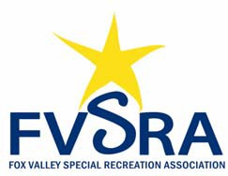

Board of Directors
Monthly Meeting Dates for FY2019‐20

Meetings are at 10:30am on the 4th Tuesday of the Month in the FVSRA Conference Room unless otherwise noted:

Tuesday, May 28, 2019
Annual Meeting

Tuesday, June 25, 2019

Tuesday, July 23, 2019

Tuesday, August 27, 2019

Tuesday, September 24, 2019

Tuesday, October 22, 2019

Tuesday, November 26, 2019

No Meeting in December, 2019

Monday, January 27, 2020*
The Board Meeting and Staff Dinner will be held at 6:00 PM

Tuesday, February 25, 2020

Tuesday, March 24, 2020

Tuesday, April 28, 2020

*exception to the 4th Tuesday

